Establishment of
Global University System (GUS)
in Sierra Leone and Mano River Union countries

Secretariat: University of Sierra Leone
College of Medicine and Allied Health Sciences

January 8, 2007

Aiah A. Gbakima, Ph.D.
Principal Organizer
Professor, Vice Chancellor & Principal
University of Sierra Leone
Private Mail bag
A. J. Momoh Street, Tower Hill
Freetown, Sierra Leone
Tel: +232-22-226859/226594
Cell: +232-76-880-758/+232-033-599-835
aiah_gbakima2000@yahoo.com

Takeshi Utsumi, Ph.D., P.E.
Co-Principal Organizer
Founder and Vice President for Technology and Coordination of Global University System (GUS)
Chairman, GLObal Systems Analysis and Simulation Association in the U.S.A. (GLOSAS/USA)
43-23 Colden Street, Flushing, NY 11355-5913, U.S.A.
Tel: 718-939-0928, utsumi@columbia.edu
http://www.itu.int/wsis/goldenbook/search/display.asp?Quest=8032562&lang=en
http://www.friends-partners.org/GLOSAS/
Tax Exempt ID: 11-2999676

Global University System

Global University System (GUS) aims to create a worldwide consortium of universities and healthcare institutions to provide the underdeveloped world with global e-learning and e-healthcare/telemedicine via broadband Internet technologies. The aim is to achieve “education and healthcare for all,” anywhere, anytime and at any pace. Education and job skills are the keys in determining a nation’s wealth and influence.

GUS is headquartered at the Global E-learning Center at the University of Tampere in Finland, under the direction of the UNESCO/UNITWIN Networking Chair, held by Dr. Tapio Vans. The GUS/Sierra Leone consortium member institutions will also become members of this Chair Program.

Mobile Assessment and Media Systems (MAMAS)

With focus on women's empowerment, MAMAS is designed in context of GUS programs, providing the Local Community Development Network (LCDN), linking universities to/from community-based clinics, schools, governmental and lifelong learning centers. MAMAS is a model for hybrid communications and international supportive partnerships, adapted to rural and refugee needs. MAMAS incorporates best practices and most advanced technology research for added value and reach to existing national and community-based programs.

GUS/Sierra Leone

This project is to create GUS/Sierra Leone, which is to be emulated in other Mano River Union (MRU) countries, i.e., Guinea, Liberia and Ivory Coast, in the near future. The MRU Secretariat will provide overall co-ordination of GUS and emerging programs.

GUS/Sierra Leone will be a consortium of University of Sierra Leone, Njala University, Milton Margai College of Education and Technology, and other local stakeholders, etc., and will serve as the overall framework for past and future initiatives entailing rural and community-based development activities, especially (not exclusively) those pertaining to health care, education, agriculture and fishing.

GUS/Sierra Leone is designed to provide tools to enable the people of the region to participate fully in their own development and to bring their culture forward, thriving with the influx of opportunities, and contributing to new prosperities. After a decade of rebel wars, GUS/Sierra Leone will provide a modernizing tool to fast-track peace-building, peace-consolidation and socio-economic development of the participating communities, and contribute to the accelerated integration of the MRU countries in the world economy, export and trade facilitation, rural and community-based economic growth.

Project concept

- Proposed GUS/Sierra Leone linked by MAMAS to rural and refugee communities, supports distance learning and e-health/telemedicine for: 1) regional technological infrastructure and 2) programs and academic content to increase stakeholder capacity.
- Both infrastructure and programs are supported by 1) exchanges of educational courses and their credits through broadband Internet, 2) promotion of community development, and 3) collaborative research.
- Immediate focus is on community e-health/telemedicine and participatory governance because those programs are foundational and best developed for rapid start-up.
- The e-university brings together resources of an extensive network of universities in Sierra Leone, as well as specialized programs from many international universities.
- GUS/Sierra Leone and MAMAS provide tools, systems, partnerships and funding opportunities to strengthen local efforts for remote learning and health system.

Working Groups of GUS/Sierra Leone

At the planning workshop (see below), following working groups will be formed.

Infrastructure

GUS programs and services will be delivered via regional satellite hubs, typically located at a major university, that connect via broadband Internet to educational resource cites in the E.U., U.S., and Japan. In a sense, the regional satellite hub is to be the major Internet Service Provider (ISP) for not-for-profit organizations in the region and the gateway to the outside world. The GUS/Sierra Leone consortium member institutions will be connected to very high speed Internet, as similar to the optical fiber network at 3 Gbps of the Multimedia Broadband Internet (MBI) of the Ethiopian government. GUS member institutions will then connect with secondary and elementary schools, libraries, hospitals, local government offices and NGOs, etc., through broadband wireless Internet at drastically discounted rates.

The buildings with a broadband Internet connection will then also become relay points for the low-cost “Wi-Fi (wireless fidelity)” networks that are now rapidly appearing in Japan, USA and Europe. This advanced wireless communication with laptop computer will make e-learning possible for anyone, anywhere, and anytime with capabilities of Internet telephony, fax, voice mail, e-mail, Web access, videoconferencing, etc. This is not only to help local community development, but also to assure close cooperation among higher, middle and lower levels of education.

In order to assure broadband Internet availability, Sierra Leone will be linked to the Infinity Worldwide Telecommunications Group of Companies, Inc.’s (IWTGC) <http://www.iwtgc.com/> ultra-high speed submarine optical fiber cable around the western African countries followed by or to the extent possible, at the same as the other MRU countries; to facilitate the laying of fiber optic cables (with combined use of wireless, where feasible) along various highways under construction and planned to be built. The aim is to provide a solid IT backbone that ensures uninterrupted Internet connectivity and satellite-driven communication systems.

Along the telecom infrastructure, adequate and appropriate solar-powered electrical energy infrastructure will be constructed to ensure Internet connectivity and availability of affordable power and related services, particularly in rural and sub-urban agglomerations for various uses including household consumption, clinics and other health centers, freezers and other storage facilities, schools and other education establishments, community centers, markets, etc.

Global E-Learning

The GUS will be anchored in universities in Sierra Leone and the other MRU countries to enhance e-learning to their students and life-long learners in their community for the development of technical and professional human capital and attendant enlightenment etc., and to ensure the sustainability of global e-learning via links with universities and other academic establishments in North America, Europe, Japan and more industrially advanced countries.

Learners will be able to take their courses from member institutions around the world to receive a GUS degree, thus freeing them from being confined to one academic culture of a single university or country. These institutions also act as the knowledge center of their community for the eradication of poverty and isolation through the use of advanced Information and Communications Technologies (ICTs).

Global E-Healthcare/Telemedicine

GUS/Sierra Leone will increase access to customized communications and related resources which mobilize and encourage hospitals and e-healthcare centres to use the Internet and hybrid technologies to provide patients online second opinion for various infectious and chronic diseases, including malaria, sickle cell anaemia, river blindness, HIV/AIDS, polio, cancer, heart disease and other conditions. Existing university and community programs will help define communications and data management systems, which reduce obstacles to good health management.

Doctors will also be taught (through a train-the-trainers program) how to use computers effectively to order tests and drugs, which has been shown in studies to reduce medical errors and flag patient drug allergies. Nurses will also be taught to use computers to track patients as they go through the primary healthcare centers and hospitals.

Medical records will be computerized, including lab results, drug data and records of office visits in text files, which would be standardized in a format that can be shared. Crosscutting priority will be to encourage government and donors to develop incentives to encourage health administrators, doctors, health workers to use the Internet.

Community Development

Learners, faculties, and public policy makers can promote community development and many other advances at a local, regional and even on a global scale. GUS/Sierra Leone consortium member institutions will act as the flagship of their community development, particularly on the facilitation of entrepreneurial initiatives for the creative economy of Knowledge Society in the 21st century.

Globally Collaborative Research and Development

The learners and their professors from participating institutions will form a global forum for exchange of ideas and information and for conducting collaborative research and development. Researchers in MRU countries can partner with colleagues in more advanced countries, and perform joint collaborative research and development with the use of virtual reality/virtual laboratories on inexpensive Beowulf mini super-computers (clusters of PCs) for experiential/constructive learning and creation of knowledge through the emerging global GRID computer networking technology.

Financing.

This GUS projects will combine (1) the Japanese government's Official Development Assistance (ODA) funds and (2) Japanese electronic equipment (including technical assistance and training) with (a) the Internet technology and (b) content development of North America and Europe.

Action Plan

Fact Finding and Assessment Trip

The first practical step in this process is the preparation of a detailed program document encapsulating the diverse components of the enterprise. This requires a fact-finding mission to Sierra Leone and MRU countries to be undertaken by Prof. Utsumi and Ms. Linda Hawkin Israel. During this period, an initial stakeholder meeting will be held for formal confirmation of project partners in Freetown, Sierra Leone, and to form working groups mentioned above. This trip must include following:

  - Visits to participating colleges, universities, hospitals, local governments and community based programs in Sierra Leone:
  - Establishment of working groups for each aspect of collaborative proposal writing, with representation from the communities, institutions, and governmental agencies that will benefit from the initiative.

Planning Workshop for Convening of Working Groups (about 4 months after the above action)

Each working group will produce proposal with necessary steps to be taken during the following half year with their budgets, which will be summarized into a proposal. This proposal with precise budget for the next design phase will be used for the fund raising. The emphasis will be placed on the design of tech/facilitator support and marketing survey for sustainability of GUS/Sierra Leone with their applications and others at anchoring institutions, mentioned above. This proposal will be submitted with endorsements from various UN, governmental, university, NGO agencies to the nearby Japan Embassy for the Japanese ODA fund.

Design Phase Workshop

This phase will conduct market survey, feasibility study, system design of infrastructure, design of support system and administration structure, as well as to construct a business model for maximum effectiveness and sustainability and replication in other locations. This phase would produce a project proposal for deployment, for which Japanese ODA fund will cooperate with federal and regional government for funding as GUS/Sierra Leone program.

Timeline/Budget.

A Phase: Fact-Finding and Assessment Trip

Time Period: March 1, 2007 to June 1, 2007
Budget: $30,000
- establishment of local secretariats to move project forward,
- confirmation of official participation,
- convening of initial stakeholders meetings in Freetown, Sierra Leone.

B Phase: Planning Workshop

Time Period: July 1, 2007 to December 31, 2007
Budget: $150,000
1) collaborative development of infrastructure, program tracks, and timelines by stake holders,
2) development of relationship with grantors,
3) written proposal, with budgets, for Japan ODA support and matching grants,
4) grants agreed upon and mechanism for administration put in place.

C Phase: Design Phase

Time Period: January 1, 2008 to July 1, 2008
GUS/Sierra Leone implemented per agreements.

References

Utsumi, T., Varis, T., and Klemm, W. R., (2003), “Creating Global University System,” Global Peace Through The Global University System, University of Tampere Press, Tampere, Finland
<http://makeashorterlink.com/?I2F231019>
Utsumi, T., (2006), “Report on Fact-Finding and Assessment Trip To Create Global University System/Altai Mir (now GUS/Siberia)” with a fund from the USAID through Eurasia Foundation
<http://tinyurl.com/te6sb>
Utsumi, T., (2006), "Globally Collaborative Innovation Network with Global University System," Paper for Learning Technology, IEEE Computer Society, Vol. 8, Issue 3, July
<http://tinyurl.com/fuwg6>
Varis, T., Utsumi, T., and Klemm, W. R., (Editors), (2003), Global Peace Through The Global University System, University of Tampere Press, Tampere, Finland, November, (ISBN 951-44-5695-5)
<http://makeashorterlink.com/?M2D252E09>

ANNEX

Support Letters
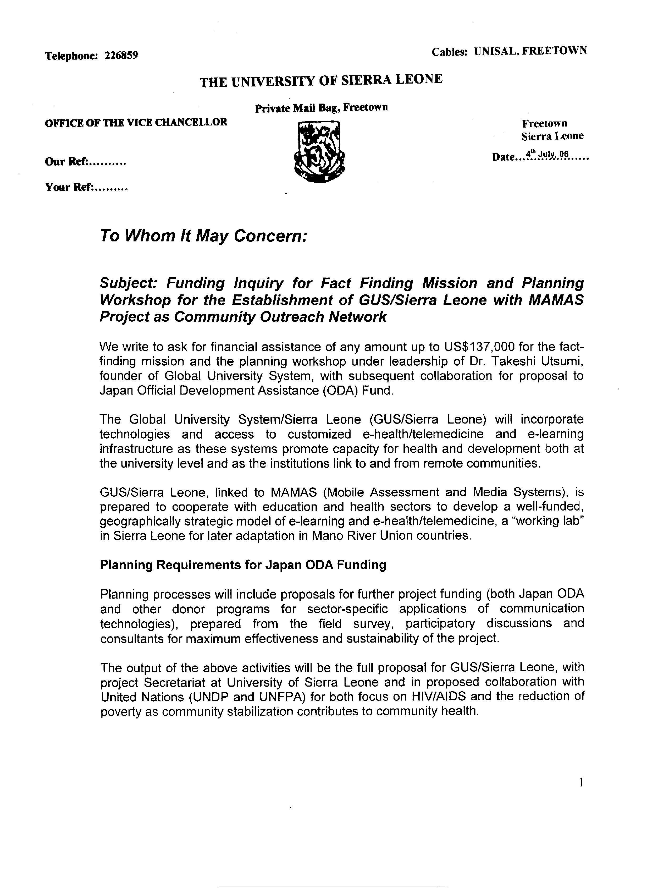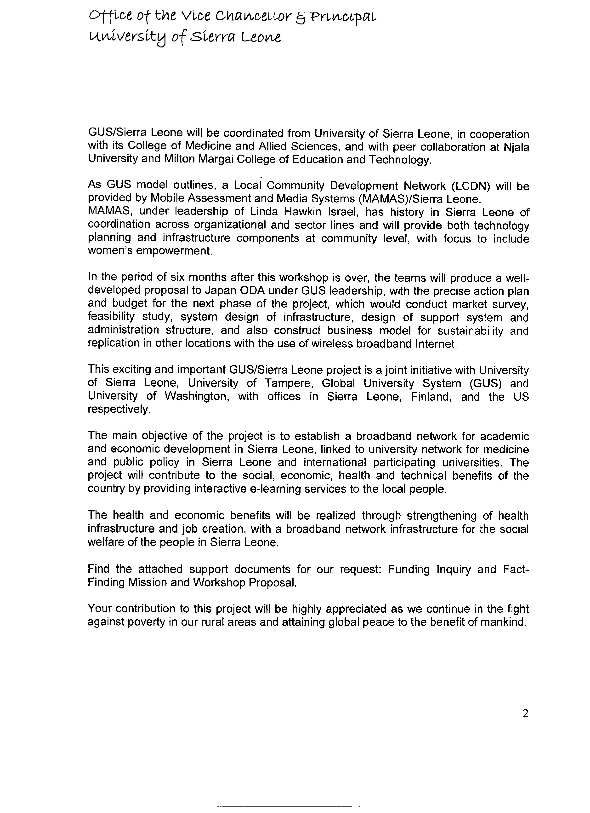
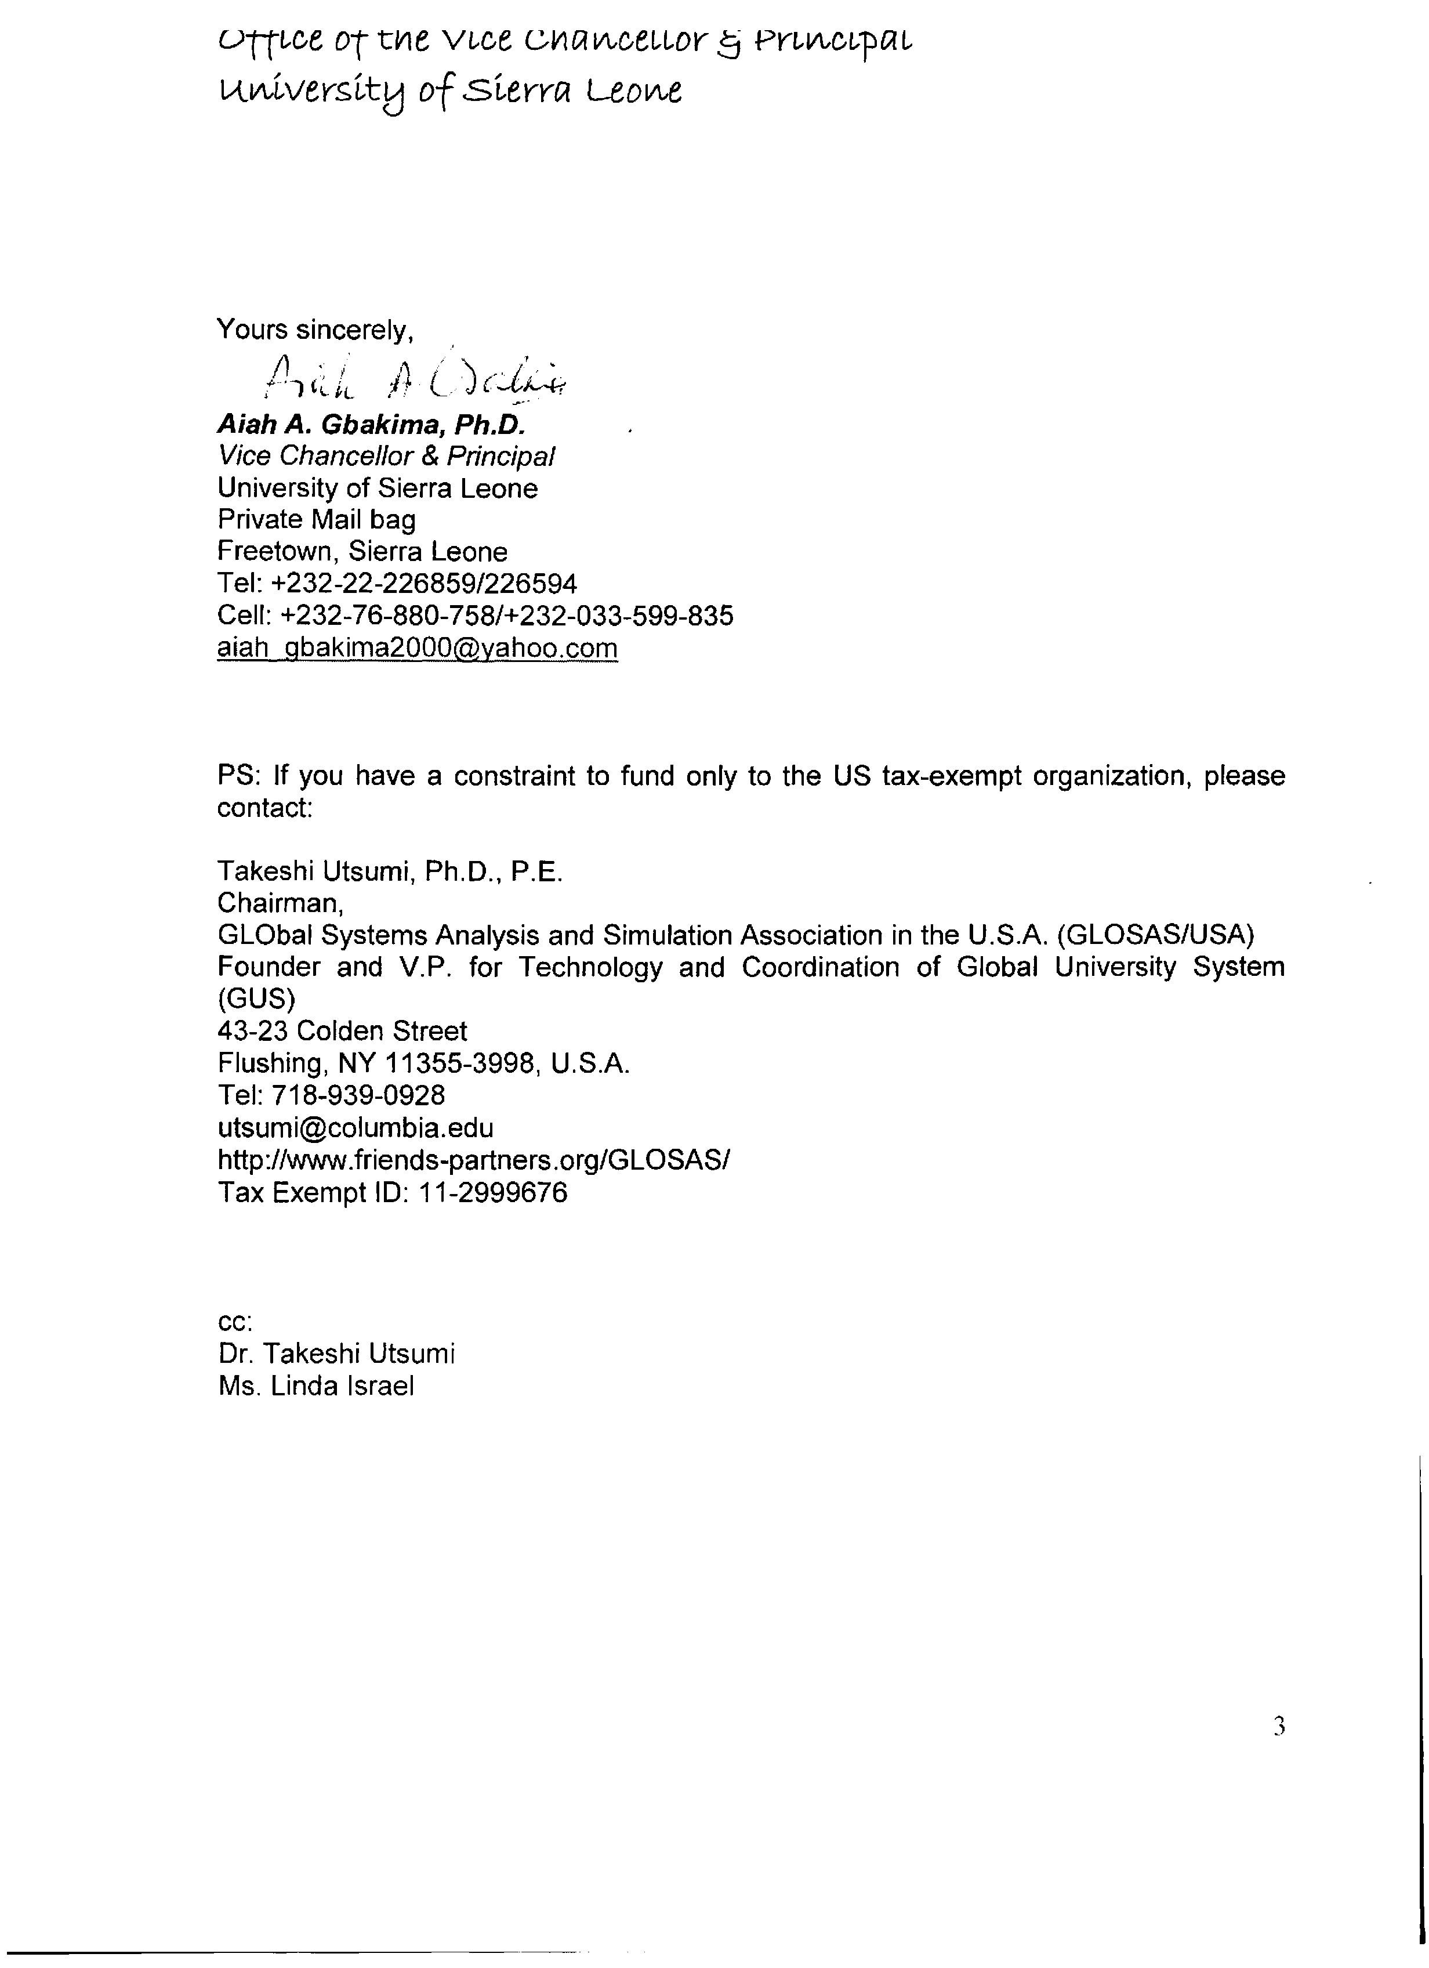
NJALA UNIVERSITY

Distance Learning and Telemedicine Network to
Build Capacity for National Recovery

As Chief Academic and Administrative Officers of Njala University, I have reviewed the well-defined technology support systems and strategic partnerships for a Global University System (GUS) broadband network with Japan ODA donor structure and propose cooperation with the GOSL Ministry of Education with planning grants by UNAIDS (for infrastructure to advance education and health services) and Fast Track Poverty Reduction (for infrastructure which initially strengthens both fishing industry rehabilitation and rural women’s farm cooperatives).

GUS for Sierra Leone has been adapted as complementary to the Mobile Assessment and Media Systems (MAMAS) outreach network for rural and refugee schools and learning centers to support acceleration of capacity-building across sectors.

In a larger context, we propose that this university-to-community educational network serve as a demonstration to help achieve MDG2015 targets, and as part of a Sierra Leone model for Association for the Development of Education in Africa (ADEA) http://www.adeanet.org/about/en_aboutADEA.html

Background
Linda Hawkin Israel (MAMAS) and Dr. Takeshi Utsumi (GUS) have presented us with an integrated and forward-leaning program outlining tools for implementation and coordination of all systems as they support basic education, participatory planning and tracking of public health and community medicine projects, with a structure under-girding education and management systems for economic development at varied levels of need. These systems can be anchored within the university networks in cooperation with international university and technology industry partners.

Over time, these capacities can increase income and security for universities, polytechs and even secondary schools as they “grow up” technical specialists and services to provide innovative community solutions.

Cross-Cutting focus:
As a cross-cutting educational program which uses these systems, MAMAS is proposing cooperation with the American Bar Association (ABA Africa Initiative), and Sierra Leone counterpart institutions and individuals, to include a track for strengthening legal infrastructure both at the university level and for legal literacy within civil society.

In cooperation with local stakeholders on development and distribution of content, this technology and peer-supportive infrastructure will expand potential for both education and dialogue with a strong focus on empowerment of women and on incorporation of lessons learned during Truth and Reconciliation hearings.

We understand that these linked models (MAMAS and GUS) represent several decades of research and international partnership-building and can are designed for ongoing reporting out, review, adaptation and eventual replication with consideration of population requirements and needs.

We also understand that Sierra Leone, its education and public health target goals, can provide the setting for a national “lab” to demonstrate a grid of technical solutions which are integrated into existing good programs and increase their potential for success both short and long term.

GUS and MAMAS: Current status
MAMAS, based at University of Washington, Seattle, and GUS, based in NYC and Tampere, Finland, represent mature programs with built-in peer support and donor strategy for a university-to-community education and telehealth network.

Both programs are ready for fast track implementation of a national “lab” demonstrating and reporting out advanced technologies as they are taught, maintained and used for sector-based needs This process builds on nearly six years of pre-planning in Sierra Leone and will precede development of small pilots linking universities to community-based learning and health programs.

Next steps and requirements
Both MAMAS and GUS teams can be in Sierra Leone to begin this stakeholder planning process beginning June 1, 06. It is estimated that each program with its field and home support personnel will require about four months delivering the following:

- demonstration workshops for sector applications
- stakeholder planning for university-to-model community integrated infrastructure
- agreements and structures for collaboration and accountability in place
- coordinated proposals to donors for each track with pre-approved funding

University of Sierra Leone, Njala University, with Milton Margai College for Science and Technology, as lead for Polytechnic network systems, will cooperate with the Ministry of Education to anchor MAMAS and GUS infrastructure as is agreed upon during planning processes.

Funding
Budget for four month planning process as outlined above is 175K. This will cover costs of multi-sector initial analyses complete to finished proposals to donors. A planning budget is available for submission upon request.

We propose that funding for this next phase planning is provided and administered within UNDP and includes both UNAIDS and the Fast Track Poverty Reduction budgets as the implications are clear for this integrative approach to accelerate progress to meet targets for both programs.

We understand that the June 15 start date for a funded planning process represents a window which must be acknowledged for these programs to be available for our use.

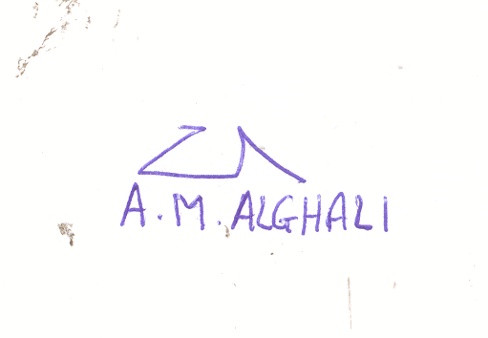
Yours faithfully
Prof. Aliyageen M Alghali
Vice-Chancellor and Principal
Njala University

College of Medicine and Allied Sciences
University of Sierra Leone
31 . 5. 2006

ENDORSEMENT GLOBAL UNIVERSITY SYSTEM ( GUS) and MOBILE ASSESMENT AND MEDIA SYSTEMS ( MAMAS) PROGRAMME FOR THE COLLEGE OF MEDICINE AND ALLIED HEALTH SCIENCES.

As Deputy Vice Chancellor and Head of University of Sierra Leone College Medicine and Allied Science, I recognize the critical role this institution has in the rehabilitation and human capacity building of the health sector in Sierra Leone.

It is with real anticipation that I endorse the Global University System (GUS) and Mobile Assessment and Media Systems (MAMAS) as telehealth broadband for universities and hospitals, and for (MAMAS) hybrid communications with alternative energy support for remote and refugee communities.

It has been my pleasure to have reviewed the well-defined technology support systems and strategic partnerships for a Global University System (GUS) broadband network with Japan ODA donor structure, linked to a Mobile Assessment and Media Systems (MAMAS) outreach network for rural and refugee schools and learning centers.

The College of Medicine is involved directly and indirectly to support multiple approaches for community health, with knowledge that access to information and participatory planning are necessary at each level of public education training of the nations medical manpower, research, professional education at the university level and sustainable health policy and planning.

We endorse UNDP and UNFPA cooperation to seek and administer a planning grant, with University of Sierra Leone College of Medicine, to assist both GUS and MAMAS for in-country and international university support which will enable us to plan a course and develop proposals to meet Japan ODA and other donor bank funding requirements.

We understand that telehealth (trainings, public information) and telemedicine (professional peer support, access to medical libraries via internet, web-conferencing and consulting for diagnoses and ongoing education is foundational for our medical advancement.

Prof Sahr Moses Gevao
Deputy Vice Chancellor and Head.
College of Medicine and Allied Health Sciences.
University of SierraLeone.
Tel 0023276601613
E mail gevaosm@yahoo.com

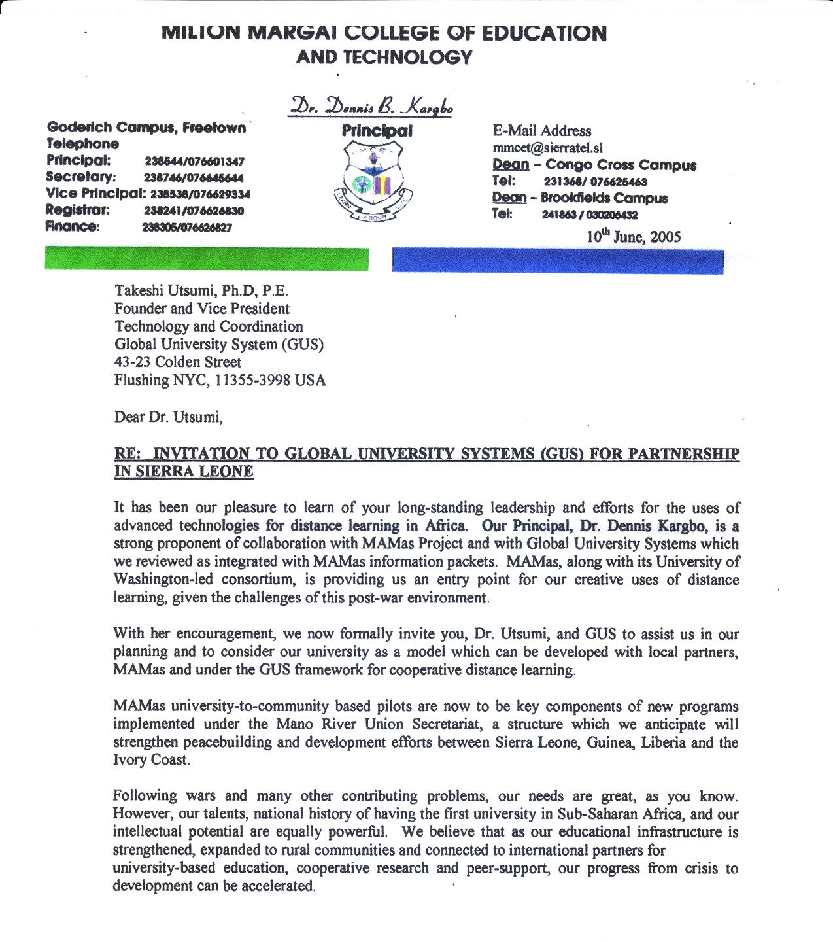
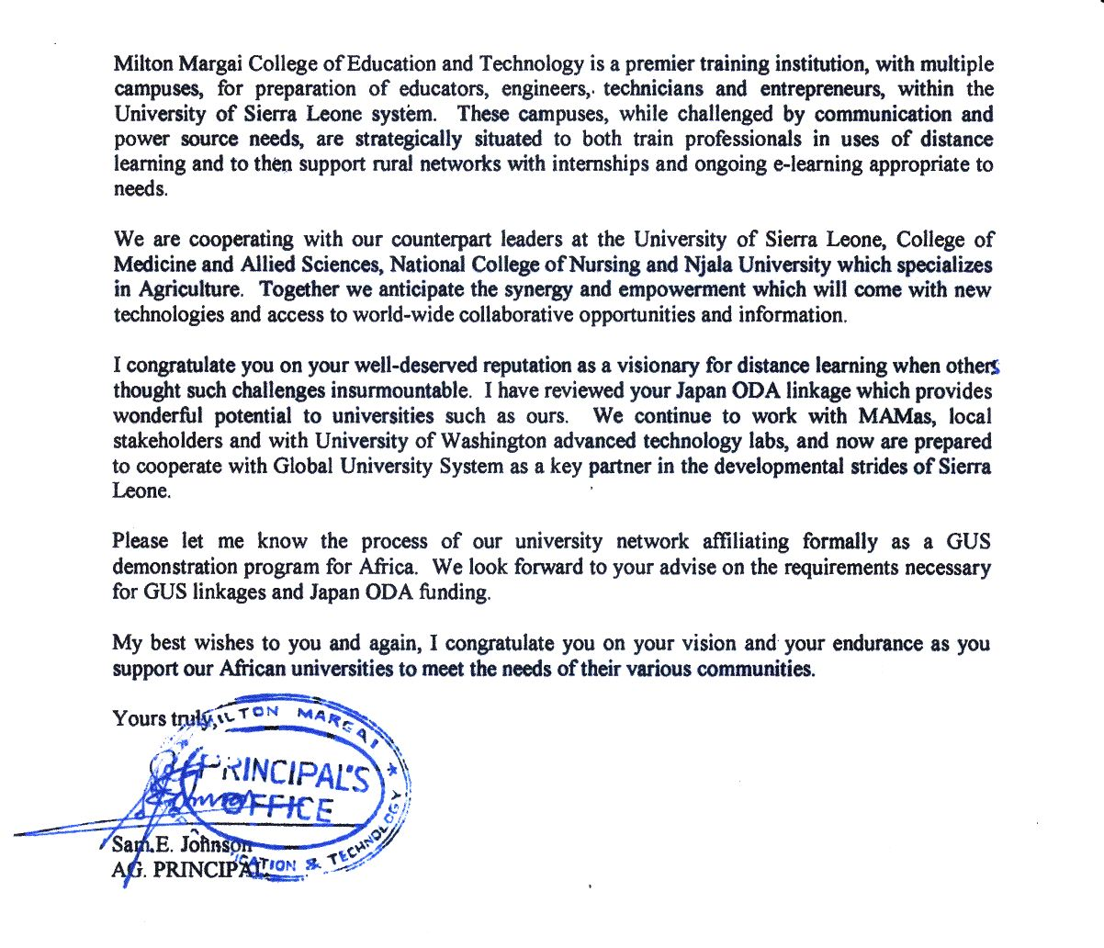
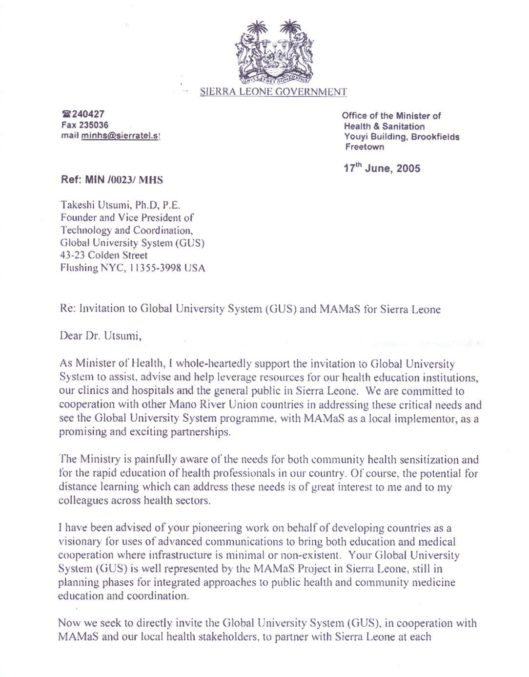
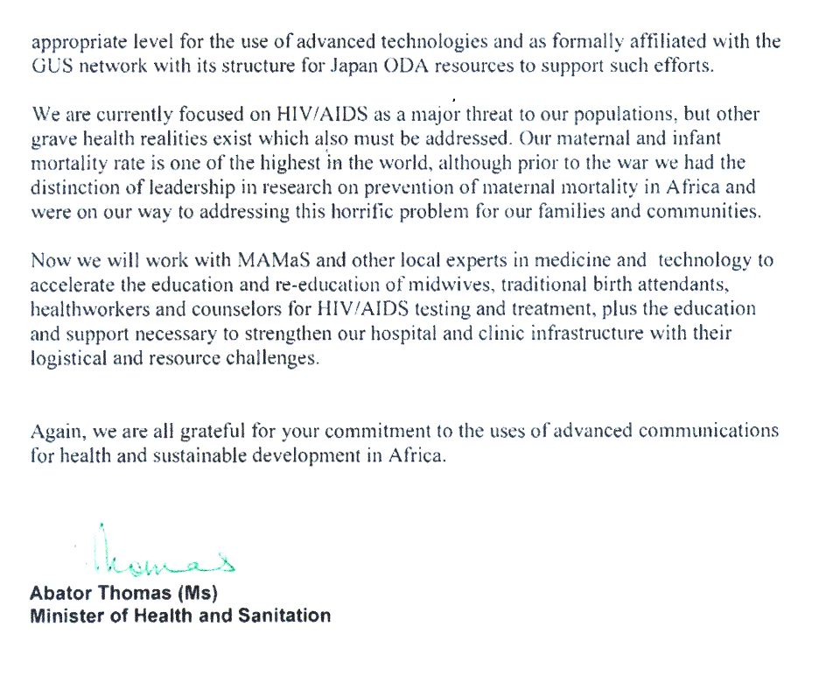
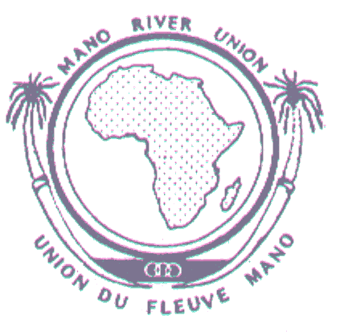

The Secretary General

Ref: 69/MRU/SG/05 Date: 24/07/2005

Dear Dr. Utsumi,

RE: Invitation

Mano River Union Secretariat’s Invitation to Global University System (GUS)

It is with great pleasure and anticipation that I greet you from Freetown, Sierra Leone where I serve as Secretary General of the Mano River Union Secretariat. This office, in cooperation with the United Nations and sub-regional governments, provides a mechanism for collaboration between Sierra Leone, Guinea, Liberia and the Ivory Coast which is currently included due to destructive cross-border dynamics during and following rebel wars.

As you know, these countries are inter-twined in their histories and cultures and are now attempting to recover from a decade of rebel conflict, displacement of populations, breakdown of infrastructure and general disruption of civil society. Each sector must now participate for intra-regional, national and community-wide rehabilitation.

Compounding the challenges of rehabilitation is the growing dread of HIV/AIDS and how this disease may affect our populations, given the presence of so many contributing factors.

Mano River Union Secretariat’s Interest in Global University System (GUS)

Ms. Linda Hawkin Israel, MAMaS Director, has briefed me, along with key stakeholders in this sub-region, as to the value of affiliation with you and with GUS. I congratulate you on your forward-leaning vision to bring together universities, donor groups and local stakeholders for the purpose of energizing the universities and educational infrastructure necessary for sustainable development in Africa. Your approach for consistency of planning and leveraging of resources is commendable and we look forward to further cooperation.

Invitation

Considering these possibilities, the Mano River Union Secretariat invites you to come for an assessment and planning mission where we will meet with educators, community-based leadership and at which time we can discuss all possibilities further. We will continue to cooperate with MAMaS as liaison between us for next phase analysis of needs.

Again, I congratulate you on your leadership for inclusion of advanced communications for education, health and development in Africa.

